[MAJOR TASKS]
TASK 1: NETWORK INFO
• ip a = 10.0.0.80
• hostname –I = 10.0.0.80
TASK 2: CONNECTIVITY TEST
• ping =
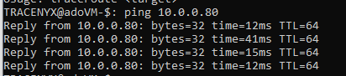
• traceroute =
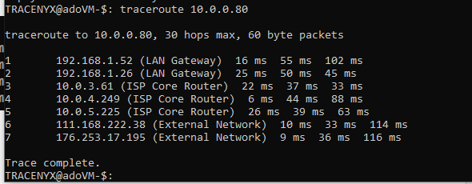
TASK 3: DNS ANALYSIS
• nslookup = unknown host
• dig = unknown host
TASK 4: PORT SCANNING
• nmap = host seems down
• nmap –sV = unknown host
• nmap –A = unknown host
TASK 5: TRAFFIC MONITORING
tcpdump -i Ethernet
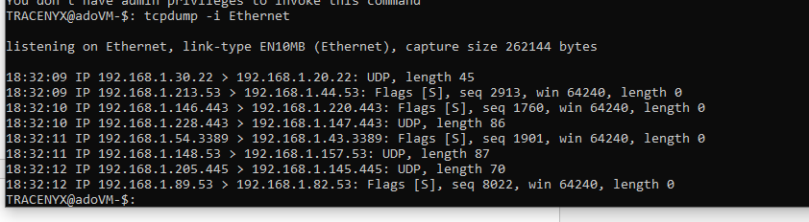
TASK 6: DEVICE DISCOVERY
• arp-scan –localnet = You don’t have admin privileges to invoke this command.
• sudo arp-scan –localnet
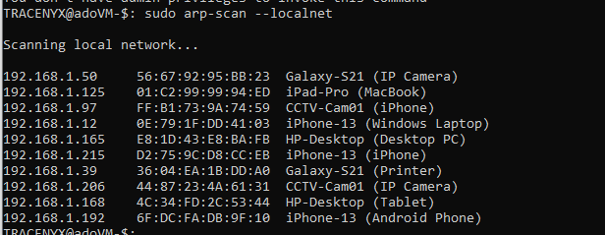
TASK 7: LOGS & FILES
• ls
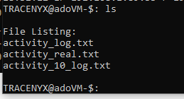
• cat
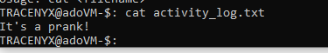
• wget
